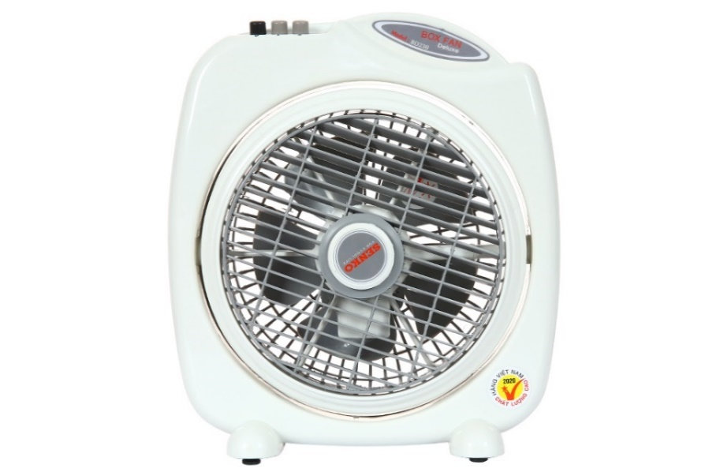

**240.000₫**

~~290.000₫~~ -17%

**Technical specifications Senko 5-blade box fan BD230 28W**

* Fan Type:

[Box fan](https://www.dienmayxanh.com/kinh-nghiem-hay/cac-loai-quat-pho-bien-tren-thi-truong-845793#quat-hop) - 28W - 2 wind levels

* Fan diameter:

5 petals - 20 cm

* Wind mode:

Normal wind

* Dashboard:

Button

* Motor type:

Silver brazing

* Utilities:

The switch and wire connection protection parts are made of fireproof material. The fan cage has a small fan blade gap

* Size, volume:

Width 27.3 cm - Height 31 cm - Depth 11 cm - Weight 1.5 kg

* Brand of:

Vietnam

* Launch year:

2016

Introducing the company 

- Vietnamese brand.

- Established in 1998.

- With the mission "Cooling for life", SENKO electric fans meet all customer needs and are the perfect choice for every home for table fans, hanging fans, mezzanine fans, standing fans, ceiling fans, etc. .

- High quality, beautiful design, and energy saving are the core criteria in every Senko electric fan product.

***Senko BD230 box fan effectively cools with 5 blades and 28W capacity to help save electricity, brass motor with 100% durable copper wire material, smooth operation.***

**Product design**

- Compact design, easy to place in many positions, suitable for many spaces, convenient for desktop use.

- Senko BD230 box [fan](https://www.dienmayxanh.com/quat)  has 5 blades with a blade diameter of 20 cm for stronger airflow, effectively cooling small spaces.

- Has a handle on top for easy holding, weight only 1.5 kg, easy to move to many places.

- Has an air vent that automatically rotates when the fan operates, helping the air flow to spread wider, improving cooling ability.

- You can adjust the wind blowing angle up and down by changing the direction of the fan cage manually.

- Power cord length 186 cm for convenient portability.

**Motor type and operating capacity**

- Senko [box fan](https://www.dienmayxanh.com/quat-hop) is equipped with a brass motor made from 100% copper wire to help the fan operate durably, with little corrosion, giving the fan a long life and comfortable use in quiet spaces.

- 28W capacity for effective cooling air flow of 17 m 3 /minute.

- The product is granted a 4-star energy label, capable of saving electricity well.

See more:  [Tips for preserving electric fans](https://www.dienmayxanh.com/kinh-nghiem-hay/meo-bao-quan-quat-dien-536092)

**Wind level, wind mode**

-  [Senko BD230 fan](https://www.dienmayxanh.com/quat-senko)  has 2 wind levels: strong - weak, helping you customize the appropriate level according to your needs.

[- Equipped with a normal wind](https://www.dienmayxanh.com/kinh-nghiem-hay/cac-tien-ich-cua-quat-dien-hien-nay-phan-1-845369#gio-thuong) mode : the fan will blow out the wind at a steady speed without alternating with the strong or weak rhythm.

**Dashboard**

Push button control panel, easy to operate and customize 2 wind levels to suit your needs.

**Utilities**

- The fan cage has a small fan blade gap, safe for close contact.

- Switches and wire connection protection parts are made of fireproof material, heat-resistant enough, ensuring safety when used.

[*Senko BD230 box fan*](https://www.dienmayxanh.com/quat/hop-senko-bd230)*from the Senko - Vietnam brand is recognized as a Vietnamese product - high quality helps cool effectively with 5 blades and 28W capacity, compact design suitable for motel rooms and bedrooms. work,... have a small space.*